**Lesson 02 Demo 01**

**React Routing example**

**Objective:** To demonstrate the react routing to navigate different component like Home component, about us component and contact us components.

**Tools required:** Node JS and React JS

**Prerequisites:** HTML, CSS, JavaScript ES5/ES6, Basic React Concept

**Note** : All react js project already created with version 18.x with Sample App.js file

**Steps to be followed:**

1. Set up for react js project
2. Using npm command install routing dependencies.
3. Enable BrowserRouter features in index.js file
4. Now you need to create Home, About Us and Contact Us component
5. Now create NavBar.js component file which contains Route link rules.
6. Add the bootstrap features to project
7. Import all component in app.js file and write the rules in App.js file
8. Now test the application

**Step 1: Set up for react js project**

1. Open a terminal window inside a React JS pre-created project ie **simple-react-app-routing**

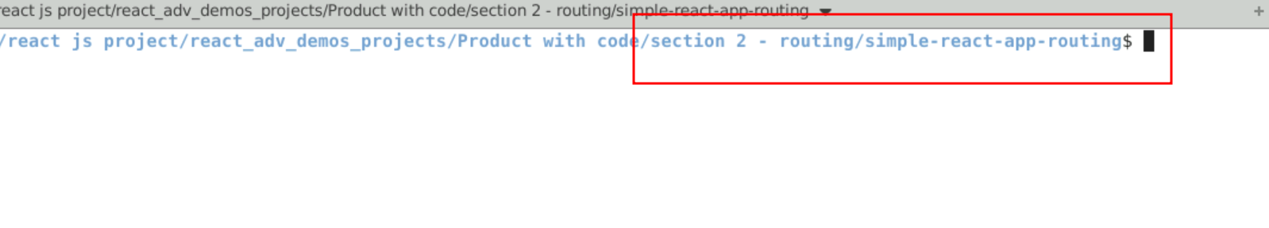

1. Now you need to run the command as **npm install.** This command helps us to installed all required dependencies mention in package.json file in local machine in the form of node_module folder.

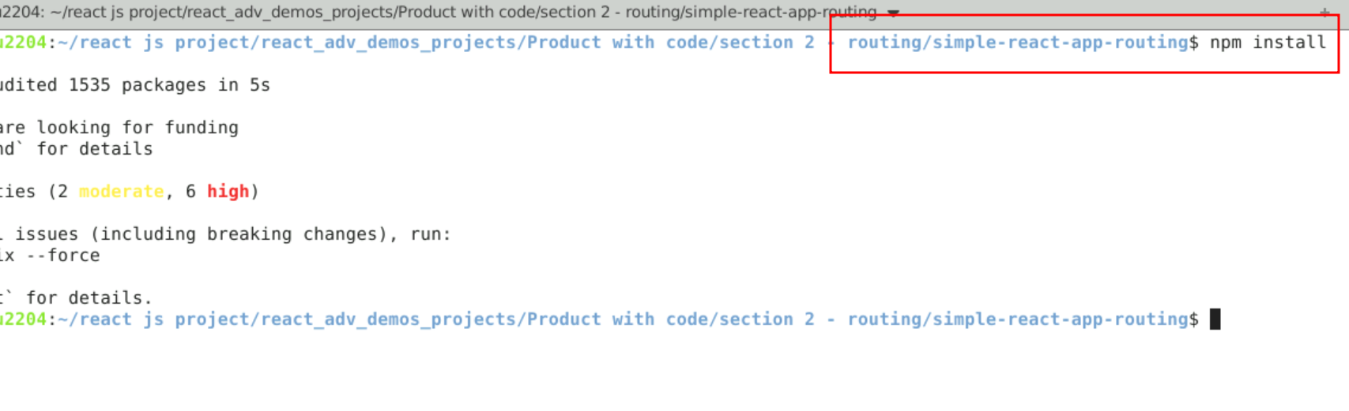

1. Now open **simple-react-app-routing** folder in VS Code Editor

Note: short cut to open write **code .**

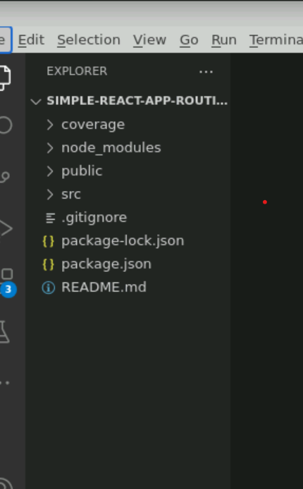

**Step 2:** Using npm command install routing dependencies.

1. **npm install react-router-dom**

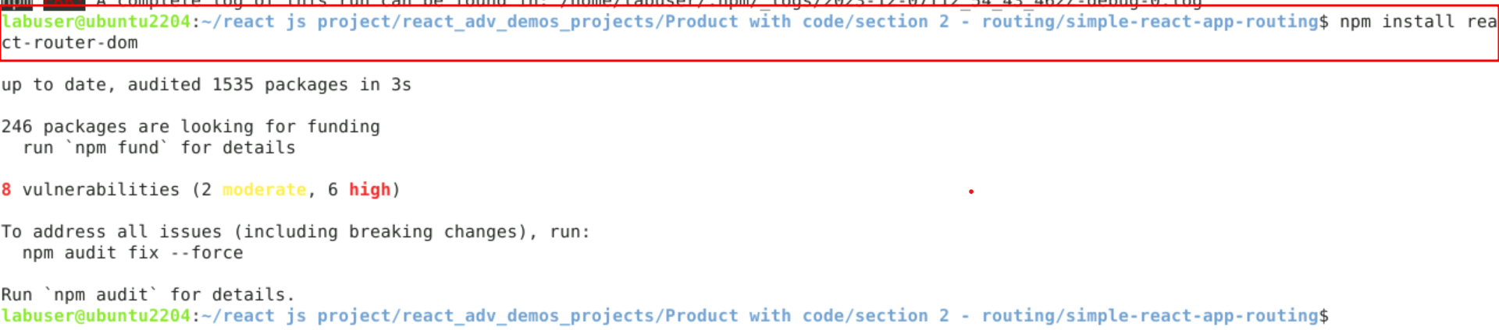

2.2. View the react-router-dom dependencies in package.json file

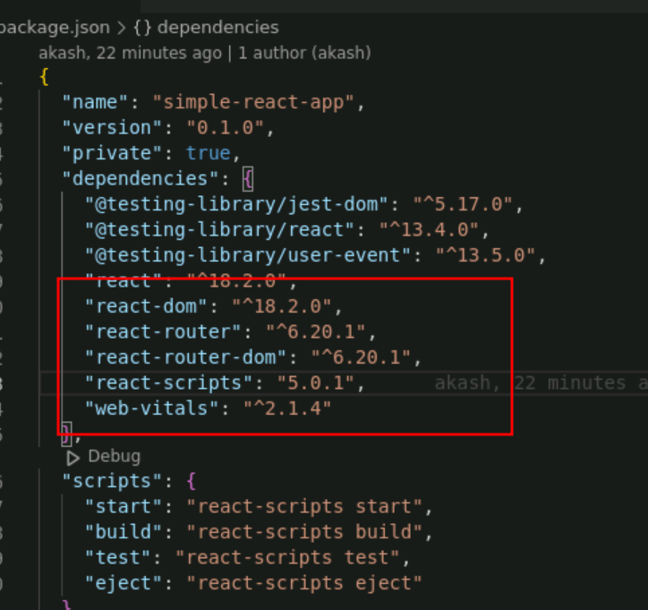

**Step 3:** Enable BrowserRouter features in index.js file

3.1 Now open the index.js file and add the BrowserRouter tag which help to enable to routing features to whole application. Ie Root tag.

Index.js code

import React from 'react';

import ReactDOM from 'react-dom/client';

import './index.css';

import App from './App';

import reportWebVitals from './reportWebVitals';

import {BrowserRouter} from 'react-router-dom'

const root = ReactDOM.createRoot(document.getElementById('root'));

root.render(

<React.StrictMode>

<BrowserRouter>

<App />

</BrowserRouter>

</React.StrictMode>

);

// If you want to start measuring performance in your app, pass a function

// to log results (for example: reportWebVitals(console.log))

// or send to an analytics endpoint. Learn more: https://bit.ly/CRA-vitals

reportWebVitals();

3.2 Screen short for the changes done in App.js file

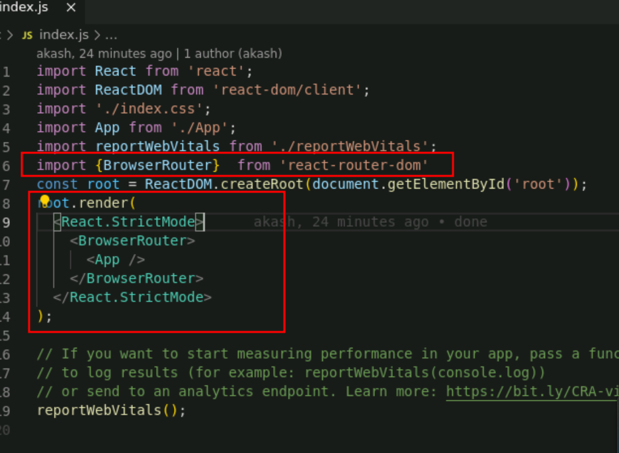

**Step 4: Now you need to create Home, About Us and Contact Us component**

4.1 Create the Home.js component file

function Home() {

return(

<div>

<h2>Home Component</h2>

</div>

)

}

export default Home;

4.2 Create About.js component file

function About() {

return(

<div>

<h2>About Us Component</h2>

</div>

)

}

export default About;

4.3. Create Contact.js component file

function Contact() {

return(

<div>

<h2>Contact Component</h2>

</div>

)

}

export default Contact;

**Step 5: Now create NavBar.js component file which contains Route link rules**

5.1 This file contains Route rules which help to navigate from one component to another component. The below code or NavBar.js file

import React from 'react';

import { NavLink } from 'react-router-dom';

const NavBar = () => {

return (

<div>

<nav>

<div className="nav-items container">

<div className="logo">

<a href="/">

<h1>Router App</h1>

</a>

</div>

<ul>

<li>

<NavLink to="/">Home</NavLink>

</li>

<li>

<NavLink to="/about">About Us</NavLink>

</li>

<li>

<NavLink to="/contact">Contact Us</NavLink>

</li>

</ul>

</div>

</nav>

</div>

);

};

export default NavBar;

**Step 6: Add the bootstrap features to project**

6.1 Add the bootstrap CDN link in index.html page

<link href="https://cdn.jsdelivr.net/npm/bootstrap@5.0.2/dist/css/bootstrap.min.css" rel="stylesheet" integrity="sha384-EVSTQN3/azprG1Anm3QDgpJLIm9Nao0Yz1ztcQTwFspd3yD65VohhpuuCOmLASjC" crossorigin="anonymous">

6.2 Screen short of index.html page code after added link of bootstrap

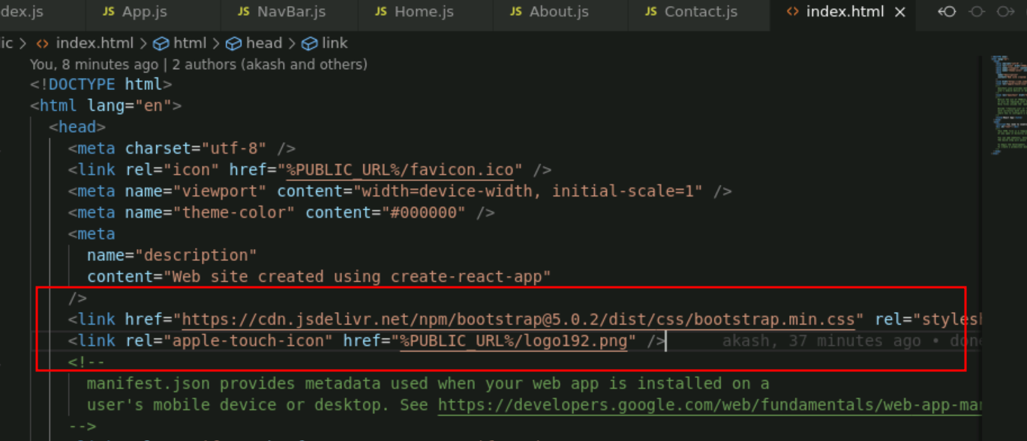

**Step 6 : Add the bootstrap features to project**

6.1 open the app.js file.

import logo from './logo.svg';

import './App.css';

import WithoutUseMemo from './WithoutUseMemo';

import WithUseMemo from './WithUseMemo';

import UseMemoWithDependency from './UseMemoWithDependency';

function App() {

  return (

    <div className="App">

      <WithoutUseMemo></WithoutUseMemo>

      <WithUseMemo></WithUseMemo>

      <UseMemoWithDependency></UseMemoWithDependency>

    </div>

  );

}

export default App;

**Step 7. Import all component in app.js file and write the rules in App.js file**

7.1 App.js file : inside this file contains all component Route rules and NavBar component contains all component link ie hyperlink which help to navigate.

import './App.css';

import {Routes,Route, Link} from 'react-router-dom'

import Home from './Home';

import About from './About';

import Contact from './Contact';

import NavBar from './NavBar';

function App() {

return (

<div className="App">

<NavBar />

<hr/>

<Routes>

<Route path="/" element={<Home/>}></Route>

<Route path="/about" element={<About/>}></Route>

<Route path="/contact" element={<Contact/>}></Route>

</Routes>

</div>

);

}

export default App;

**Step 8. Now test the application**

**8.1 npm start**

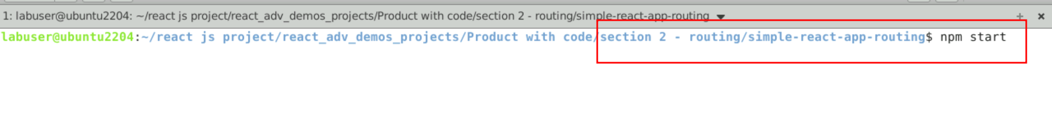

**8.2 See the output on browser**

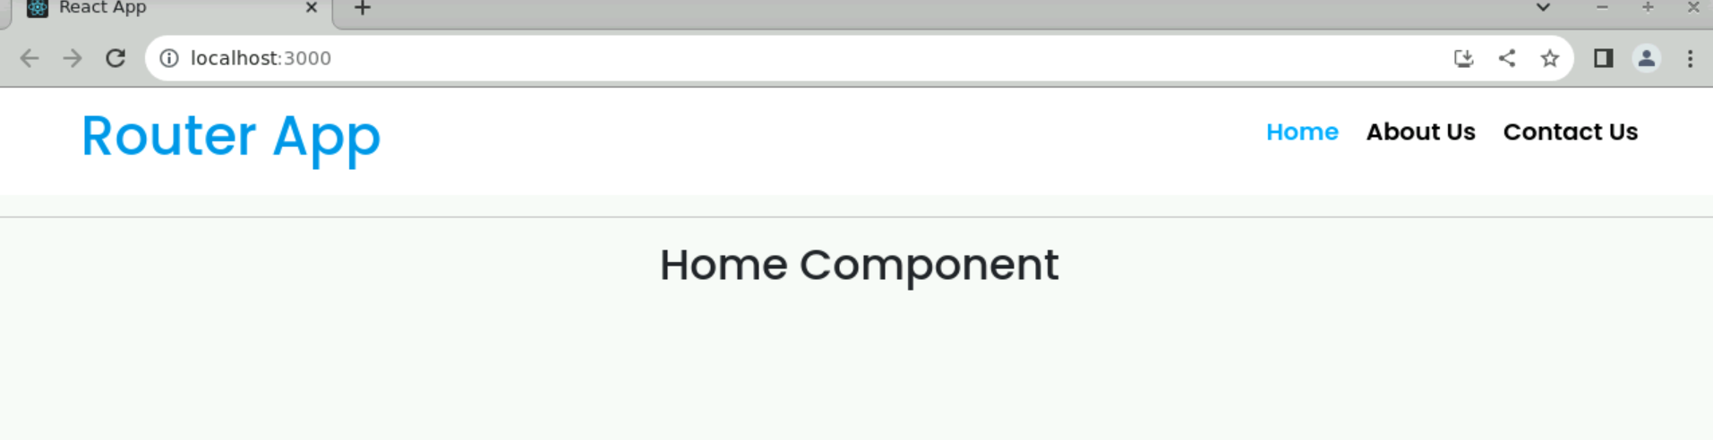

**8.3 Please test with About Us and Contact us component**

